# **Pizza Sales Queries**

* **KPI’S**

**1. Total Revenue**

select sum(total_price) as Total_Revenue from pizza_sales

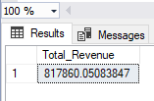

**2. Average Order Value**

select sum(total_price)/ COUNT(distinct order_id) as Avg_Order_Value from pizza_sales

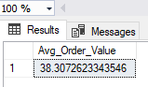

**3.Total Pizzas Sold**

select sum(quantity) as Total_Pizzas_Sold from pizza_sales

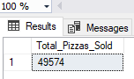

**4. Total Order Placed**

select count(distinct order_id) as Total_Orders from pizza_sales

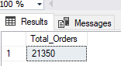

**5.Average Pizzas Per order**

select cast(cast(sum(quantity) AS decimal (10,2)) / CAST(count(distinct order_id) AS decimal(10,2)) AS decimal(10,2)) as Avg_Pizzas_Per_Orders from pizza_sales

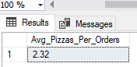

* **Charts Requirement**
* **Daily Trend For Total Orders**

select DATENAME(DW,order_date) as order_day, count (distinct order_id)as Total_Orders

from pizza_sales

group by DATENAME(DW,order_date)

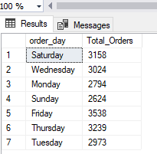

* **Monthly Trend For Total Orders**

select DATENAME(MONTH,order_date) as Month_Name, count (distinct order_id)as Total_Orders

from pizza_sales

group by DATENAME(MONTH,order_date)

Order by Total_Orders desc

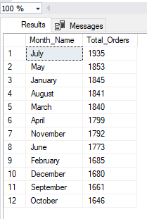

* **Percentage of sales by pizza category**

select pizza_category,sum(total_price) as Total_sales,sum(total_price)*100 / (select sum(total_price) from pizza_sales ) as Percentage_of_total_sales

from pizza_sales

group by pizza_category

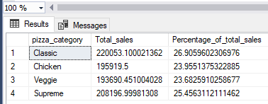

**Using Month filter**

select pizza_category,sum(total_price) as Total_sales,sum(total_price)*100 / (select sum(total_price) from pizza_sales where MONTH(order_date)=1) as Percentage_of_total_sales

from pizza_sales

where MONTH(order_date)=1

group by pizza_category

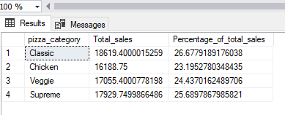

* **Percentage of sales by pizza Size**

select pizza_size,sum(total_price) as Total_sales,sum(total_price)*100 / (select sum(total_price) from pizza_sales where MONTH(order_date)=1 ) as Percentage_of_total_sales

from pizza_sales

group by pizza_size

order by Percentage_of_total_sales desc

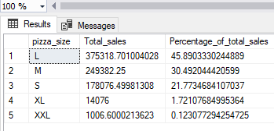

**Using cast only for 2 decimel point with where clause**

select pizza_size,cast(sum(total_price) AS decimal(10,2)) as Total_sales, cast(sum(total_price)*100 /

(select sum(total_price) from pizza_sales WHERE DATEPART(quarter,order_date)=1) AS decimal(10,2)) as Percentage_of_total_sales

from pizza_sales

WHERE DATEPART(quarter,order_date)=1

group by pizza_size

order by Percentage_of_total_sales desc

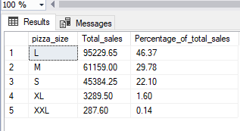

**Top 5 Pizza By Revenue**

select top 5 pizza_name,sum(total_price) as Total_sales from pizza_sales

group by pizza_name

order by Total_sales desc

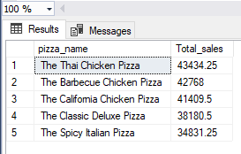

**Bottom 5 Pizza By Revenue**

select top 5 pizza_name,sum(total_price) as Total_sales from pizza_sales

group by pizza_name

order by Total_sales asc

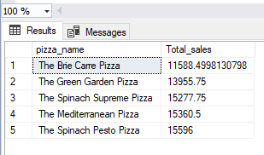

**Top 5 Pizza By Quantity**

select top 5 pizza_name,sum(quantity) as Total_Quantity from pizza_sales

group by pizza_name

order by Total_Quantity desc

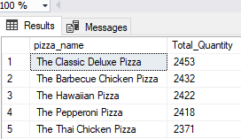

**Bottom 5 Pizza By Quantity**

select top 5 pizza_name,sum(quantity) as Total_Quantity from pizza_sales

group by pizza_name

order by Total_Quantity asc

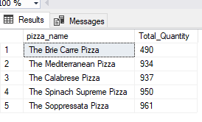

**Total Pizzas Sold by Pizza Category**

SELECT pizza_category, SUM(quantity) as Total_Quantity_Sold

FROM pizza_sales

WHERE MONTH(order_date) = 2

GROUP BY pizza_category

ORDER BY Total_Quantity_Sold DESC

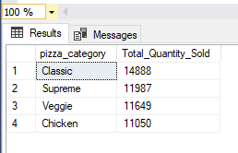

**Top 5 Pizzas by Total orders**

SELECT Top 5 pizza_name, COUNT(DISTINCT order_id) AS Total_Orders

FROM pizza_sales

GROUP BY pizza_name

ORDER BY Total_Orders Desc

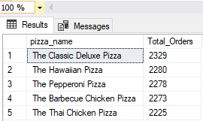

**Bottom 5 Pizzas by Total orders**

SELECT Top 5 pizza_name, COUNT(DISTINCT order_id) AS Total_Orders

FROM pizza_sales

GROUP BY pizza_name

ORDER BY Total_Orders ASC

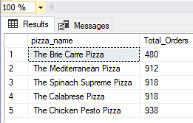

**With where filter**

SELECT Top 5 pizza_name, COUNT(DISTINCT order_id) AS Total_Orders

FROM pizza_sales

WHERE pizza_category = 'Classic'

GROUP BY pizza_name

ORDER BY Total_Orders ASC

